STEM ACTIVITY PACK

PHY01

“Frozen”

Task 1: Primary/Early Secondary School - Ages 5-13
Task 2: Primary/Early Secondary School - Ages 5-13
Task 3: Primary School – Ages 4+
Length: 2-3 hours total
Contents
1. SUMMARY OF ACTIVITY 3
2. RISK ASSESSMENT 3
3. EQUIPMENT LIST 4
4. TIMELINE 5
5. PRIOR TO EVENT 5
6. SET UP 5
7. TASKS 6
7.1. Elsa’s Powers Part 1 6
7.1.1. DESCRIPTION 6
7.1.2. EQUIPMENT 6
7.1.3. METHOD 6
7.1.4. LEARNING OUTCOMES 7
7.2. Elsa’s Powers Part 2 8
7.2.1. DESCRIPTION 8
7.2.2. EQUIPMENT 8
7.2.3. METHOD 8
7.2.4. LEARNING OUTCOMES 8
7.3. Olaf 9
7.3.1. DESCRIPTION 9
7.3.2. EQUIPMENT 9
7.3.3. METHOD 9
7.3.4. LEARNING OUTCOMES 9
7.4. Project 10
8. CLEAR UP 10
9. FEEDBACK/CONCLUSIONS 10
10. PARTING MESSAGE 10

SUMMARY OF ACTIVITY
This set of activities is based around the Disney film ‘Frozen’. The basic idea is that something quite familiar to many young people will bring an interest in the science behind the film and allow them to relate to the physical principles.
The activities are aimed to teach young people about basic thermodynamics and different phases of matter & how they behave. It relates to physics and chemistry parts of the curriculum involving matter.
The 3 activities involve:
- Attempting to make ice instantly (Elsa’s Powers part 1) involves talking about energy, phase change and nucleation.
- Making frost (Elsa’s powers part 2) to discuss condensation & thermal energy.
- Making pretend snow in order to mould into shapes and see how it behaves in order to discuss phases of matter and the meteorological conditions required environmentally for snow to form (Olaf).

RISK ASSESSMENT
Please complete Appendix 1: Risk Assessment Template prior to undertaking this activity.
Risk assessments for the activities (or specific activity if only choosing one) should be carried out by the STEM Ambassador/coordinator in partnership with the school involved prior to the activity being carried out. This is because there are some variables that a generic risk assessment may not take into account, such as the specific requirements of the school or whether or not the children may be allowed to attempt to carry out the tasks themselves or just watch a demonstration.

EQUIPMENT LIST
Equipment | Quantity | Consumable | Location
Paper | 10 | Yes | In pack
Pens | 5 | No | Box 12, shelf 3
Two (or Four) 1 litre bottles of water (deionised water for car batteries works best, but you could use filtered water) |  | Yes
Access to a freezer |  | - | School provides
8kg ice cubes |  | Yes | School provides
Paper towel x no. of experiments |  | Yes | School provides
Clean tin can x no. of experiments |  | No | Shelf z
A clear mixing bowl |  | No | Shelf x
3.5kg Table salt + (Salt for Elsa’s Powers Part 2 x no. of experiments) |  | Yes
Towel |  | No | Shelf y
Fake snow ingredients (11oz sensitive shaving cream, 32oz cornstarch or same ratio. Silver glitter optional) – may need to be multiplied up depending on class size |  | Yes | STEM Ambassador to provide via Sellafield

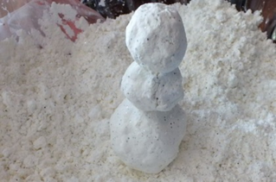
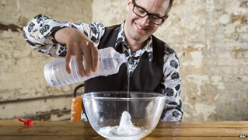
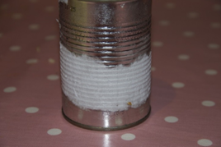

TIMELINE

Milestone / Task | Start Time | Finish Time | Duration
Welcome/introduction | 00:00 | 00:10 | 00:10
Elsa’s Powers Part 1 | 00:10 | 00:40 | 00:30
Elsa’s Powers Part 2 | 00:40 | 01:00 | 00:20
Olaf Activity | 01:00 | 01:40 | 00:40
Feedback | 01:40 | 01:50 | 00:10
Summarise | 01:50 | 01:55 | 00:05

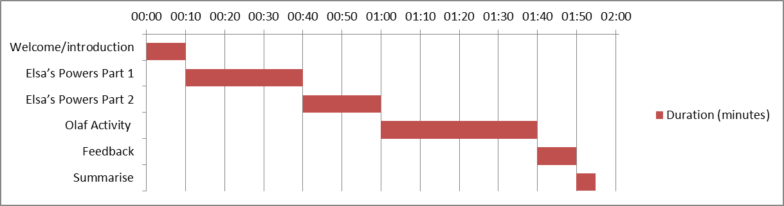

PRIOR TO EVENT
- Check equipment.
- Print out project sheets if required.
- Trial-run if unfamiliar with the experiments.
- Watch the film “Frozen” if completing the activities under the Frozen theme.

SET UP
- Layout of room
- Speak to the school about putting the water bottles in the freezer. You will need to get them to trial this one day and time it as the time may be adjusted slightly depending on the power of the freezer. You want the water as cold as possible without it being ice.
The Elsa’s Powers Part 1 experiment can sometimes fail if a bottle is knocked by accident. You can increase your chances of success by putting two bottles of deionised water in each bucket.

TASKS

Elsa’s Powers Part 1

DESCRIPTION
This activity involves an investigation into nucleation. We are going to attempt to create instant ice just like Elsa. It is recommended that the ambassador demonstrates as opposed to students carrying out this experiment.

EQUIPMENT
- Two 1 litre bottles of water (deionised water for car batteries works best, but you could use filtered water) – or as many as you think you’ll need to make the experiment work, don’t forget to have enough salt if you increase the amount of water
- A thermometer (optional)
- A clear mixing bowl
- Two buckets
- 8kg of ice cubes
- 3kg of table salt
- Towel

METHOD
There are 3 things you can do in this task. Pouring the freezer-cooled water onto a bowl of ice cubes, drop an ice-cube into the freezer-cooled water or giving the side of the bottle of freezer-cooled water a sharp bang with a small object.
Firstly, it’s important to have as many bottles of water as you feel you will need for the experiment to work. If you knock a bottle accidentally, it will freeze instantly. You will need to liaise with the school in terms of using their freezers.
- Place a bottle of deionised water into a bucket and pack 3kg of ice around the base of the bottle. Leave a few ice cubes aside in the freezer, to use later. Pour 1.5kg of salt over the ice and top up with water until it fills the bucket to the level of the bottle's lid. Repeat the process with the second bucket and bottle.
- Do not disturb your bottles while they are cooling, as the smallest knock can start the ice crystallisation process. Carefully check the temperature of the water using a thermometer. You need to wait for it to cool down to -8C. This process will take around 30 minutes.
- Carefully take one of your bottles out of its bucket and check it is still liquid water. Place it on the table.
- Take the ice cubes you set aside and place into a mixing bowl. Now gently unscrew the top of your water bottle and slowly pour onto the ice cubes. Watch in amazement as the water turns instantly into ice!
- Now carefully lift out the other bottle of water from its ice bucket. Gently wipe it over with a towel. Then, holding it firmly by the lid, give it a sharp tap on the table. You should soon see ice begin to form at the top of the bottle and 'creep' downwards.
[Credit to the BBC for step-by-step instructions]
Explanation of what’s happening
In just under 3 hours, the bottles of water have been chilled to -24 °C (-11 °F). Of course, individual settings on freezers will likely alter the time and temperature it will take to supercool the water.
The energy generated from firm hit on the side of the bottle forces the supercooled water molecules to form a crystal in a process called nucleation. That nucleus ice crystal is all that’s needed to start a chain reaction of crystallization throughout the entire bottle. Shaking or jostling the bottle has the same effect, so be very careful and have a steady hand when removing the water from your freezer.
The other reactions shown in the video work for the same reason. Pouring the water onto a bowl of ice cubes forms a slushy ice. As the supercooled water hits the ice cube nuclei in the bowl, the crystallization spreads up the stream of the water as it gets poured onto the pile. The latent heat that is released during the freezing process stops it from freezing solid.
Dropping an ice cube directly down into a glass or just touching an ice cube to the surface of the water provides the nucleus needed for the supercooled water to freeze completely.
[Credit to IFLScience for their simple explanation of nucleation. Don’t say the full name of IFLScience or recommend the page to the students as the title includes a swearword but it is an excellent resource]

LEARNING OUTCOMES
The learning outcomes depend on the age/ability of the students involved. Please see below:
Young Primary:
- States of matter
- Basic particle motion in different states of matter
- Temperature
Older primary:
- All the above
- How heat moves (basic overview of the laws of thermodynamics) – hot things next to cold things mean some of the heat energy will be transferred from the hot thing to the cold thing.
Young Secondary:
- All of the above
- Nucleation - When water freezes, it needs a nucleus in order for the solid crystals to form and become ice. Water is typically full of particles and impurities which have no problem kicking off the crystallization process. However, purified water by definition doesn’t have those impurities. Thus we can cool it below 0 degrees centigrade.

Elsa’s Powers Part 2

DESCRIPTION
This experiment involves making frost appear on the outside of a tin can. There is a lot of science going on here, and I encourage the Ambassador and the Teacher to arrange for the children to do this experiment themselves.

EQUIPMENT

Wet Paper towel x no. of experiments
Clean tin can x no. of experiments
Table salt x no. of experiments
Crushed ice and a bit of water x no. of experiments

METHOD
This is a very simple experiment that all the students can do.
1. Fill the tin can about half full with ice and add some salt and water.
2. Place the tin can on a damp paper towel to ensure water vapour present.
3. Wait and watch the frost form on the outside of the can.

LEARNING OUTCOMES
In this experiment we filled a tin can with crushed ice and a bit of water. This makes the water and the can sit at around the freezing point of water (zero degrees centigrade). However we need a subzero temperature for water to freeze normally and we get around this by adding salt. Salt lowers the melting point of ice, but by doing so it means that the surface of the can is actually below freezing point. This makes the water vapour in the air condense and freeze on the can.
Look closely at the frost; you can see crystals of ice growing on each other. Next time you see frost outside take a closer look!

Olaf

DESCRIPTION
This experiment is designed to be a fun break from classroom-based learning for primary school children in particular. The activity involves making fake snow (you could bring the fake snow prepared already, or have the children prepare it on the day as part of the task depending on time pressures). Once the fake snow is made, the children must design the best snowman they can with it. It is important to get across some of the science involved here – particularly all about real snow and the meteorological conditions we need for real snow. Don’t forget to mention why Olaf can’t have warm hugs!

EQUIPMENT
Fake snow ingredients (11oz sensitive shaving cream, 32oz corn-starch or same ratio. Silver glitter optional) – may need to be multiplied up depending on class size

METHOD
Add a small amount of shaving cream to your corn-starch. Work in the full amount of shaving cream little by little until you get the desired consistency for your fake snow. Requires a lot of kneading in order to ensure no corn-starch dust when it is being moulded. Should feel dry to the touch and not stick to your hands when it is the desired consistency. Add glitter if you wish!
ENSURE you tell the children NOT to eat the fake snow.

LEARNING OUTCOMES
Snow is when tiny ice crystals are formed in the atmosphere, then stick together to form snowflakes which fall when it is snowing. Give the children a bit of an idea about when it snows in the UK and the conditions required for snow.
From the MET Office:
Precipitation falls as snow when the air temperature is below 2 °C. It is a myth that it needs to be below zero to snow. In fact, in this country, the heaviest snow falls tend to occur when the air temperature is between zero and 2 °C. The falling snow does begin to melt as soon as the temperature rises above freezing, but as the melting process begins, the air around the snowflake is cooled.
If the temperature is warmer than 2 °C then the snowflake will melt and fall as sleet rather than snow, and if it's warmer still, it will be rain.

Project
Elsa’s Powers Pt.2 or Olaf can be left as a project for the children to do without the STEM Ambassador present, depending on the teacher’s preferences and the time slot allocated.

CLEAR UP
- All consumable products will need to be replaced.
- There may be a lot of water around from the two experiments involving water
- There may be fake snow to clean up, which can be brushed up or gathered in paper towels and put into a regular bin

FEEDBACK/CONCLUSIONS
- Summary to students
- Feedback from students (tick boxes rather than text boxes)
- Feedback from ambassador using pack (improvements)

PARTING MESSAGE
Next time it snows or you see ice/frost, remember to take a closer look!
If you leave the door open and somebody says “you’re letting the cold in!” you can say “cold doesn’t move; only heat moves!”

